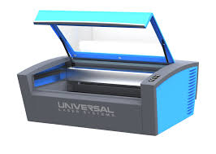Using Robots To Make UH Jewelry at the

Robotic Swarm Control Lab

Laser cutter

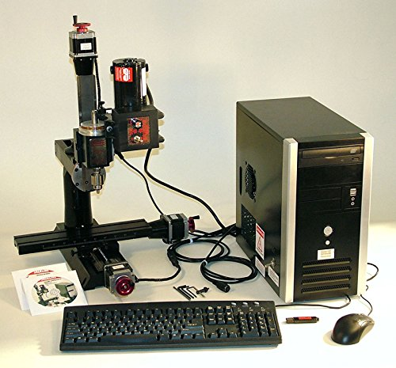

1. Use the laser cutter to slice engraved Texas shapes from wood. You can reposition the template on a free part of the wood
2. [**need safety glasses**] Use the CNC robot to drill a vertical hope through the Texas shape [or] use the drill press
3. Push a silver Eye Pin through the hole in the Texas shape with the eyelet down.
4. Use a Micro Soft Wire Cutter to trim the eye pin.
5. 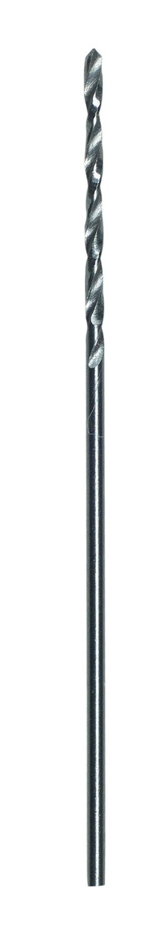Use a Round Nose Micro Pliers [or] a needle nose pliers to bend the eye pin around an Earring Hook.

CNC mill

1. 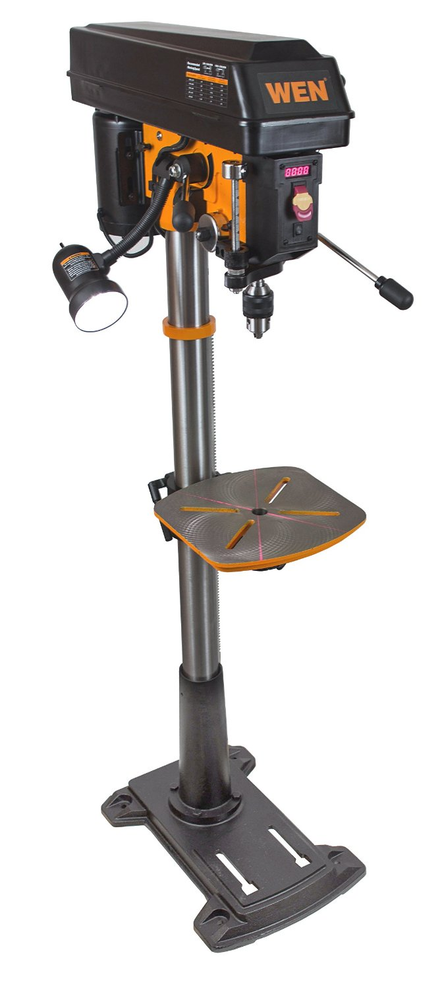[optional] paint the logo red using nail polish

Wire cutter, round nose plier, needle nose plier

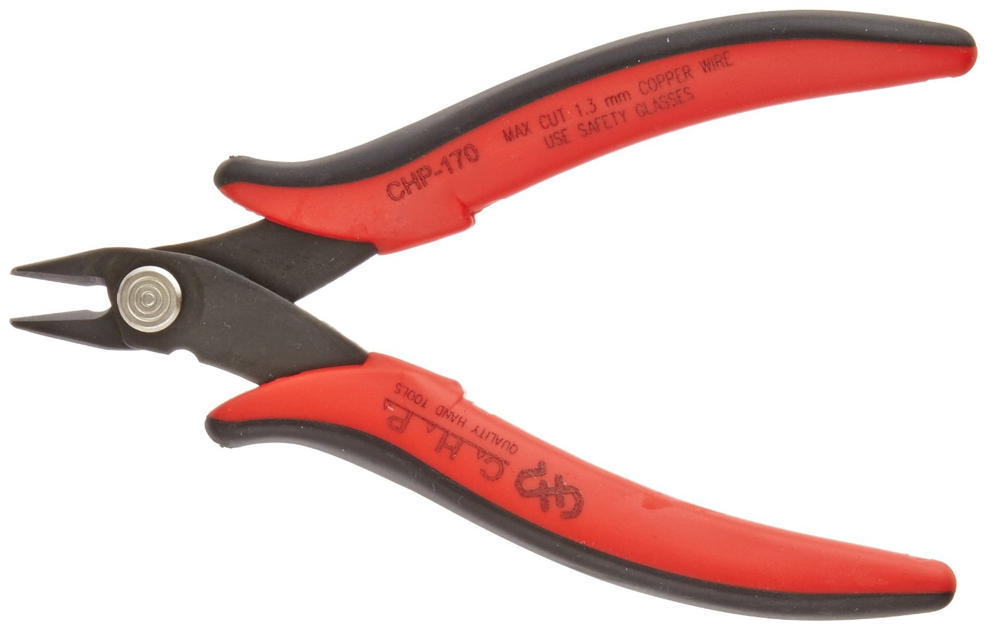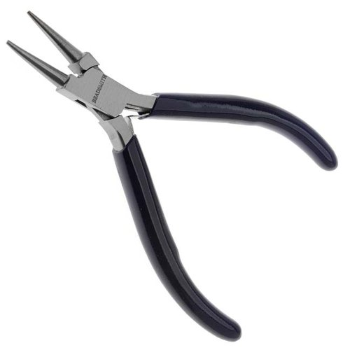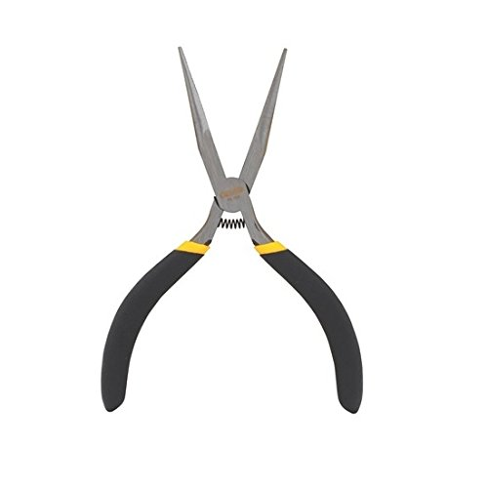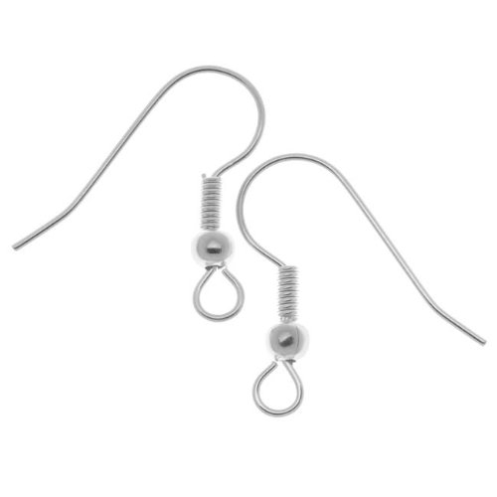

Eye pin, Earring hooks, nail polish

Drill bit, drill press

We had a huge crowd!

Next year:

1. cut out 200 earrings beforehand (enough for 100 girls)
2. use the large drill bit for drilling holes, have two stations
3. give free earrings to the organizers downstairs
4. have all robots on – floor cleaning robot, 3D printer, drawing bot, eggbot
5. take more pictures

Our job is to help the visitors have fun and to enjoy robots

Be safe – demonstrate good practices, wear the safety glasses.

We want the visitors to do as much of the process as possible – help them run the CNC, help them pick a position for the next laser cut shape, etc.

Take lots of pictures

We want to do most of the assembly in the hallway – this protects people and the lab

**Beforehand** –

1. cut out as many Texas shapes as possible, open all the packages,
2. setup assembly stations in the hallway (both sides of the long table)
3. Practice making an earring

It takes 30 seconds to drill one earring

It takes 1 minute to laser cut a Texas shape.